***STEPS OF PROCESS***

STEP : 1. Registared my self on Github by Entering college email id….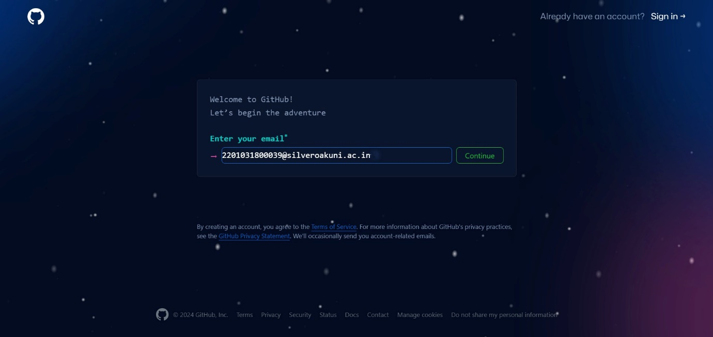

STEP : 2. Then Entered my Password.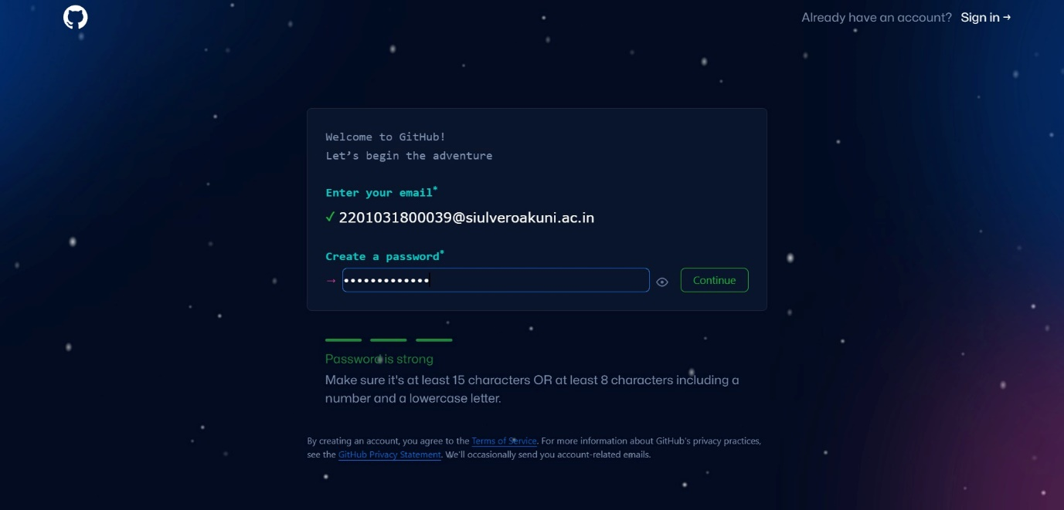

STEP : 3. After That Select Username And

Done With Verification.

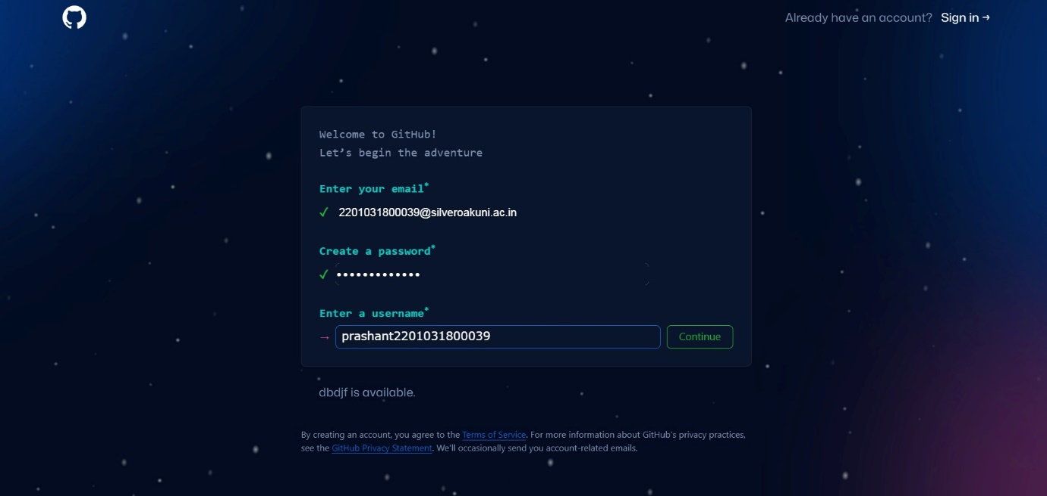

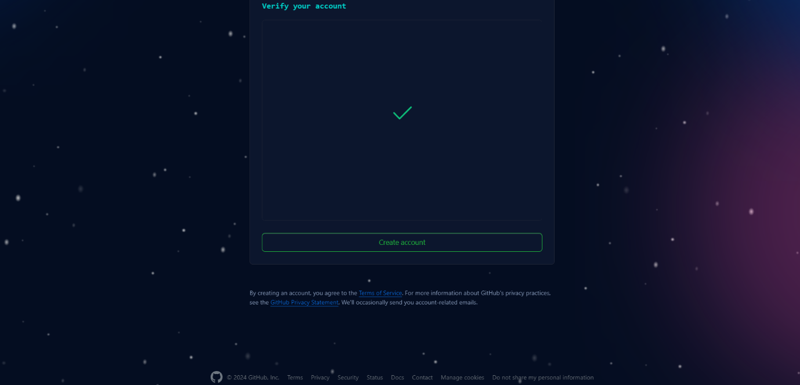

STEP : 4. So Now My Github Account has been created successfully after completing personalization….





STEP : 4. After all of These I Created Repositiery Name as my Enrollment number 2201031800039 Containing Two folder name Assignment_1 and Assignment_2.

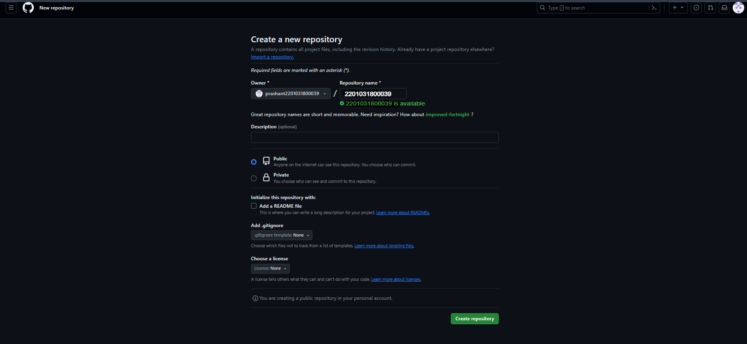

*END*